Group 1C

Engineering 1182

Dr. Ita

9/20/2021

**Problem Definition**

**Task**

Given the events that have occurred over the past years, “today, millions of college students study online and more than one-quarter of all higher education students will take at least one online course.” (Best Colleges Online) The task chosen was attending zoom meetings for college classes while living in the dorms. The following chart shows the different ways that the user interacts with this task.

**User Experience Chart**

|  |  |  |  |  |  |  |  |  |
| --- | --- | --- | --- | --- | --- | --- | --- | --- |
|  | Leave the room dorm | Find a good place to sit that has a desk and is fairly quiet | Plug in the laptop | Sit in a chair for a long time | Listen to the speaker | Take notes | Talk on the zoom call | Type in the chat or use the reaction buttons |
| **++** |  |  |  |  |  |  |  |  |
| **+** |  |  |  |  | X |  |  | X |
| **0** |  |  |  |  |  | X |  |  |
| **-** | X |  | X | X |  |  |  |  |
| **--** |  | X |  |  |  |  | X |  |

User Experience Chart: Details of the user experience when performing this task

**Pains**

The pains are the negative effects that the user might experience if this task is not improved.

* Not being engaged with the call
* Having distractions
* Unstable internet
* Being uncomfortable

**Gains**

The gains are what the user stands to gain from the improvement of this task

* Can focus for longer
* Better grades
* Studying at one's own comfort
* More privacy
* Easier communication, no background noise

**Research Plan**

**Introduction**

After identifying our task, we conducted research to analyze how the user interacted with this task and identify their needs. “Opinions on distance learning vary greatly one month into the school year as students navigate new territory.” (Searle) Attending zoom classes has many challenges such as avoiding distractions, staying focused, internet stability, and sitting for long periods. A table of the different user parts of this task that the user experiences along with a list of pains and gains can be found in Appendix A. The following chart lists research questions that will facilitate an understanding of the users’ needs. It also lists sources where data to answer these questions can be found.

**Research Questions**

|  |  |  |
| --- | --- | --- |
| **Research Question** | **Qualitative Data Collection** | **Quantitative Data Collection** |
| Where do students usually do their zoom calls? What issues do they encounter in these places, what do you like about them? | Web article containing their opinions on the good and bad parts of zoom classes (Rimer, 2020) |  |
| How do online classes affect students differently than in person classes? What is their favorite part of doing zoom classes? | A web article that reports students favorite and least favorite parts of zoom classes (Staff, 2020) | A research article on the challenges of transitioning to zoom (likert data included) (Serhan, 2020)  A research study analyzing the benefits and detriments of zoom (Shahid, 2021) |
| Is learning material harder or easier through zoom? | Web article containing interviews with multiple college students about their thoughts of in-person vs online classes (Cyr, 2021) |  |
| What technology is required for zoom calls? | Article of college student about the preparation needed for online courses (Meinke, 2020) |  |
| How many zoom calls does the average student have to attend a week? What percent of classes are online for undergraduate college students in the U.S.? |  | Zoom user stats (Dean, 2021) |
| What time of day are zoom classes usually scheduled? | An opinion article on how the timing of zoom classes can lead to zoom fatigue (Blum, 2020) | A survey about zoom usage (Abaci & Goodrum, 2016) |
| How do zoom calls affect college students differently than other students? | A news article about the specific challenges that colleges face when doing zoom classes (Amenabar, 2020) |  |

Research Questions: Questions identified about user needs to be answered through research

**Discussion**

The goals for the research we are conducting is to find the best way for students who live in dorms to have the best zoom experience for online classes. We focused on the essentials of a great zoom “environment”, stable internet, a quiet place, and most importantly comfort. Some of our research involved identifying when, where, and what students use to do zoom calls. For example, we found an article where students talk about how they prepare for their zoom classes (Meinke, 2020). And, we found an opinion article on the timing of zoom classes to analyze what time of day most students had zoom classes (Blum, 2020). We will also discuss the pains and gains of zoom classes, which varies from the comfort provided by staying at home to the struggles with interacting with the class. One of our research sources was an article from Boston University that helped us analyze these pains and gains by providing interviews from students where they describe their experience (Rimer, 2020). The main purpose is to be able to find the perfect set up for students to have the perfect zoom interactions. Our research table above will investigate some of the basic questions associated with zoom. We will target a student-based audience and ask them about their experiences with zoom, what they like about it and what they do not. From there after we sort out the responses and the experiences students have had with zoom then we can start to find solutions to the problems and design a clearer plan on how to move forward with zoom. Most importantly, after we talk to every student, all the information recorded about them will stay private and responses will be made anonymous. The ethical code should never be broken, and we like to keep everything confidential so for future research purposes students or anyone else can trust us.

**End User Needs**

After identifying a task and conducting thorough research about the task, the proposed end user needs were evaluated and ranked based on importance. A representative persona was created to accurately depict the end user of the product.

**User Persona**

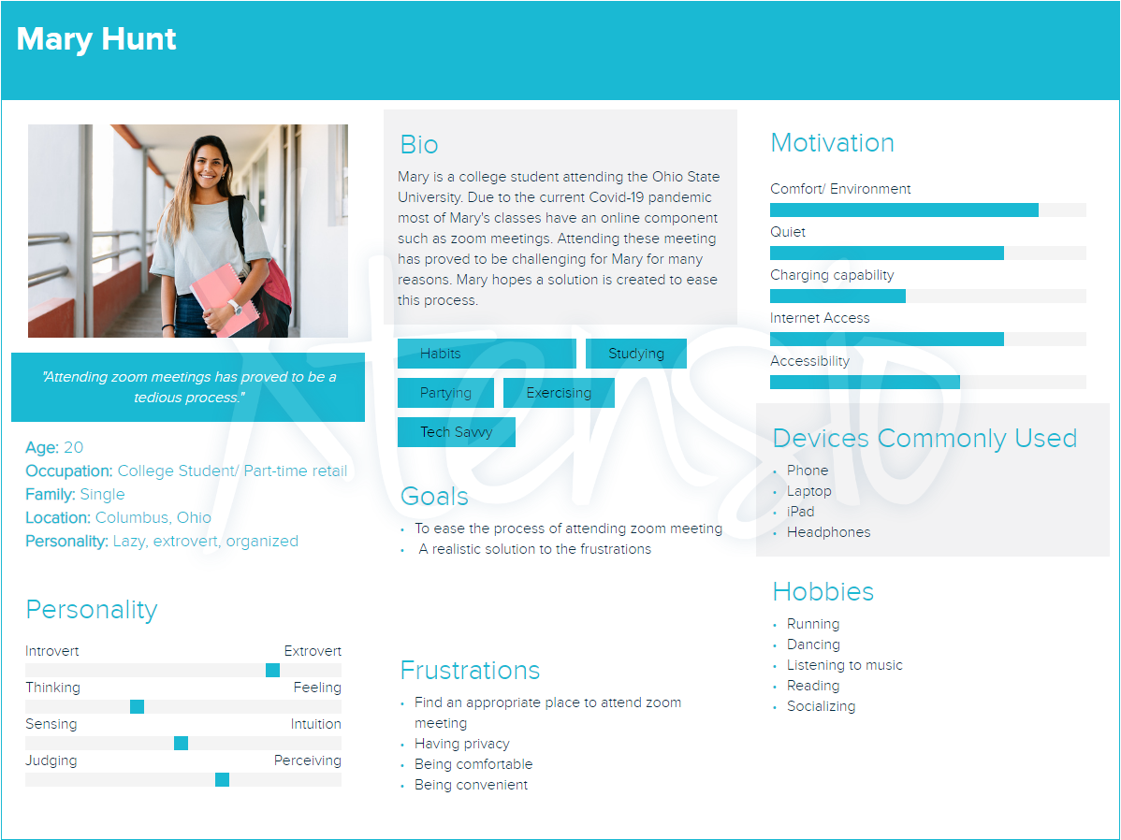

User Persona: Description of a possible end user for the product

**User Needs**

|  |  |
| --- | --- |
| User Needs | Score (1-5) |
| A quiet environment | 4 |
| A comfortable / ergonomic setup to do work | 3 |
| To get work done efficiently | 3 |
| To be able to speak and listen on zoom calls | 5 |
| An inviting environment that motivates the user to get work done | 2 |
| Be able to charge multiple devices | 1 |
| Desk space to take notes or do work | 4 |

User Needs: Different user needs ranked from 1-5 (5 being most important)

**Pairwise Comparison**

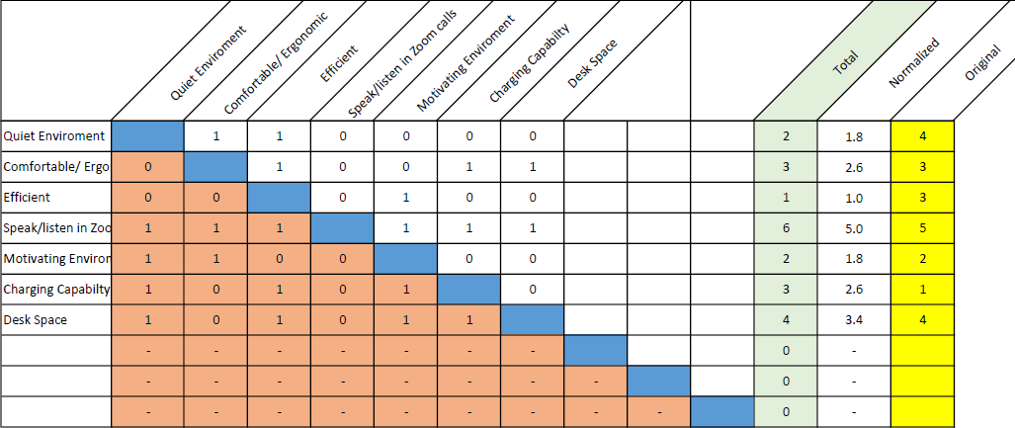

Pairwise Comparison Chart: Importance of previous user needs compared against each other

**Discussion:**

The main purpose of the End User Needs Assignment is to create a list of needs required to have a great Zoom environment and grade them in importance on a scale of 1-5 with 5 being most important and 1 being least important. Our us needs chart displays these rankings. The second part was creating the Pairwise Comparison Chart which takes the needs from the End User Needs chart and compares them. We determined the needs from the research conducted in the process of making our Research Plan.

The first user need we identified was having a quiet environment. This is essential to being able to focus, so we ranked it highly. The second was having a comfortable environment. This involves having a comfortable chair, desk, and being adjustable so that users can change the heights of both to their own preferences. While not the most important part of attending a zoom call, it would be harder to focus in an uncomfortable environment so we ranked this in the middle. Then, we identified that anything we design would have to help users get work done efficiently. We thought that this could involve some schedule or calendar designed or a space for a user to put their own calendar. This would help the user efficiently plan out their time. While it would be helpful, it is not crucial to the usability of the product. Thus, we ranked this need low. Then, we identified that users need to be able to speak and listen on zoom calls. This was the most crucial issue with attending zoom calls that we identified, so we ranked this need the highest. Next, we also thought that the product should have an inviting environment. We thought that having an aesthetically pleasing design and options for the user to customize its appearance to their own taste would motivate the user to come to class. However, it is also not crucial to the function of the product, so we ranked it low. We thought that having an easy way to charge multiple devices would be a nice bonus as users could attend class without worrying about how much battery they had left so we included this need but ranked it low. A final crucial need of the user that we identified was having desk space. We often have to take notes or do practice problems during zoom classes, so having ample desk space to do these tasks is important. The importance of the different needs compared to each other is shown in the pairwise comparison chart. We see that speaking and listening are the most important, desk space and comfortability are also crucial, and needs such as a motivating environment are just nice bonuses. Overall, these were the needs that we identified that the user would require in a product that helps them attend college classes while living in a dorm.

**Market Character**

**Stakeholders:**

* Students
  + Better focus and therefore grades
  + Less environmental awareness
  + Less interaction with others
* Students’ parents
  + benefits child’s education
  + Another cost to their kid’s education
* Universities
  + Better student participation and performance
  + More academic misconduct because classes are easier to keep online
* Professors and university staff
  + More engaged audience
  + Some of their classes may be more likely to stay on zoom if this product makes zoom classes more convenient
* Video calling companies (such as zoom)
  + More users due to greater accessibility

**Market Size:** College students living in dorms

**Possible Secondary Markets:** High school students, workplaces

**Current Alternatives:** Going to a library, going outside, using noise cancelling headphones, staying in the dorm room (and hoping the roommate is not there or is being quiet), going to a coffee shop

|  |  |  |  |  |  |
| --- | --- | --- | --- | --- | --- |
| User Need | Library | Outside | Dorm Room | Coffee Shops | Noise Cancelling Headphones |
| Quiet Environment | ☺ | X | X | X | ☺ |
| Comfort | X | X | ☺ | X | X |
| Efficient | ☺ | ☺ | ☺ | ☺ | ☺ |
| Speaking/Listening ability | X | ☺ | X | X | X |
| Motivating Environment | ☺ | X | X | ☺ | X |
| Charging Accessibility | ☺ | X | ☺ | ☺ | X |
| Desk Space | ☺ | X | ☺ | X | X |
| Internet Access | ☺ | X | ☺ | ☺ | X |

**Discussion:**

When performing a market character analysis, it is important to consider factors such as stakeholders, market size and secondary markets as well as current alternatives for your solution. We identified several stakeholders for our product. The obvious stakeholders are students who would be using the product. The product could help them focus on their classes better and achieve better grades. However, it could also lead to them being less aware of their environment and interacting less with others. Another stakeholder would be these students’ parents. The product could help the students achieve better grades. However, it could be another cost that they have to pay for. Universities would be an additional stakeholder. The product could improve the performance of college students living in dorms and lead to students interacting more in zoom classes. However, if the product makes it easier to do online classes more classes could stay online. Online classes are prone to academic misconduct, so this could be an issue for them. The professors teaching zoom classes would also be a stakeholder. The product could help their students be more engaged in class. However, if it makes zoom classes more convenient for students, universities might keep more classes on zoom. This would lead to professors having to teach more online classes. Finally, video calling companies (such as zoom) would be a final stakeholder. This product could make it more convenient for universities to use their platforms to teach classes. This would lead to more profit for these companies.

We identified several alternatives that users could use. One was going to the library, however people cannot talk when they are in the library. They can talk when they take zoom calls outside, however it is not as quiet and you cannot charge devices. Doing zoom calls in the dorm room is great for being able to talk, however it can be an unmotivating environment to do classwork and you never know if your roommate will be loud there. Coffee shops can be motivating to do work at, however they can also be loud and might have limited desk space. Noise cancelling headphones are great for being able to focus, however they don’t provide the other benefits like being motivating or providing the ability to speak. Overall, the factor that most spaces lacked was providing the ability to speak easily on a zoom call.

The main target market size for our product is college students living in dormitories along with high school students and workplaces being secondary markets. These markets experience the issues our product aims to resolve and will be the most beneficial and profitable. Current alternatives to our product include, libraries, dorm rooms, coffee shops, outdoor spaces, and the use of noise canceling headphones. After completing a competitive alternative matrix, all these locations lacked certain aspects of the user needs. Our product should focus on meeting the user needs of comfort, desk space, and being a quiet and motivating environment. Targeting these areas will produce a highly successful product.

**Value Proposition:**

Every project has its gains and pains as for this one they tend to swing depending on your personality, the reason being is if you are at your dorm you are sitting at your own comfort, but different people might translate that in different ways for instance a lot of people might not enjoy zoom calls since you are not around people and there’s less interactions with classmates. Additionally, students might find it distracting because they are at home and there’s a lot of distractions around them. On the other hand, some might like it more because they feel like they do better in their “comfort zone”, so they tend to like it more. The main goal of this project was to be able to create a perfect environment for everyone that is living in a dorm to have a great zoom experience and to be able to accommodate every student's needs. This pod should include stable Wi-Fi, which could be a major problem in dorms, eliminate noise and distractions, and with eliminating distractions you could be more engaged with the call in addition to giving you comfort and privacy to focus on the class to help understand the material better which will result in better grades.

The main end user for this project are students who live in dorms. The reason behind that is when you live in dorms you and your roommate might get in each other's way for classes. Also going to a library might limit your zoom experience due to you not being able to speak, which hinders interaction with class. So, this pod should act as your classroom for zoom calls which would eliminate distractions and give you the privacy and freedom which you might not get in your room or the library.

We feel that is project is enticing for the reasons we stated above, for consumers this can act as your own personal office for the time you use it but at your own home. Students should be able to feel a classroom environment away from the classroom. For a student the most important selling point should be the fact that the privacy afforded should help you improve your grades which is something we all strive for.

**Design Focus**

After assessing the main problem and our user needs, we have decided that we want to create a pod for students to do zoom classes in. From our research, we identified certain aspects that would make our product more marketable to our target audience. The main problem we identified that was mentioned in many of our sources, and is even a problem that we experience ourselves, is speaking on zoom calls. It can be difficult to find a quiet place where you can talk on a zoom call without disturbing anyone. Therefore, our pod will close completely around the student and be soundproof to allow them to talk easily on their zoom calls.

In an interview with Boston University students, one student pointed out Wi-Fi connection as an issue, so we decided to add space in the back of the chair to conveniently place a router for optimal signal (Rimer, 2020). In this article, a couple of students also described how they set up their workspace for zoom calls, and this highlighted that ample desk space would be important for our users. An advice piece on how to set yourself up for success for zoom calls mentioned making sure your devices are fully charged, and we thought that this was an excellent need that our product could fulfill (Amenabar, 2020). Therefore, we decided to include outlets inside the pod so the user can charge their laptop, phone, or any device that they need to use. Another one of our research articles discussed how students found time management to be more difficult in online classes. This led to the decision to include a weekly calendar whiteboard in the pod so students can manage their time better (Meinke, 2020). A final issue that we noticed was motivation. Several articles included interviews from students who mentioned that they struggle to find the motivation to do work when their classes are online, the most notable of which was a research study about students' attitudes about zoom calls (Derar, 2020). We decided that the aesthetic design of the pod would therefore be important, as having an aesthetically pleasing design would motivate students to go to class and get work done. Overall, our research led us to identify several crucial parts of our design that we would need to include.

**Appendix:**

**Appendix A**

This appendix shows the notes that were taken during the brainstorming phase of this project.

Brainstorming:

-Charging electronics

-How to prepare for a virtual class

- Checking for assignments and due dates

- Keeping track of course work

- Updating technology

- Zoom calls

* Finding place to study
* how to be Interactive through zoom

-Getting enough exercise

* walking to class
* Scheduling time for exercise

-Commuting to work

-Taking care of pets on campus

* Dog controlled garage doggy door

-Sustainable travel

* Public transit
* Electric scooters
* Walking
* COTA

-Recycling

* Knowing what to recycle

-dining halls

* Waiting in line
* all u can eat
* socializing

**Appendix B**

This appendix shows the different roles that team members took on during the assignment

Team Member Assignments

|  |  |  |  |
| --- | --- | --- | --- |
| Project Manager for Assignment | | | |
| Victoria Smith | | | |
| Deputy Manager for Assignment | | | |
| Faleh Alzoubi | | | |
| Drafted Assignment | Reviewed Assignment | Revised Assignment | Proofread Assignment |
| Faleh Alzoubi | Mohammed Abdallah | Victoria Smith | Bella Scholtes |
| Other Contributions | | | |
| Note taking for brainstorming: Bella Scholtes  Scheduling: Bella Scholtes  Document creation logistics: Faleh Alzoubi | | | |
| Problems Overcome | | | |
| * Coming up with a problem to solve * Identifying what exactly were the tasks that the user would experience with going to zoom classes * Coordinating so that the assignment was submitted on time | | | |

**Appendix C**

Sources used during the research portion of the assignment.

“How Many Students Take Online College Courses?” *Best Colleges Online*, 18 May 2021, [www.bestcollegesonline.org/faq/how-many-students-take-online-college-courses/](http://www.bestcollegesonline.org/faq/how-many-students-take-online-college-courses/).

Cyr, M., 2021. *Online vs. In-Person Classes*. College Times: Required Reading. http://www.ecollegetimes.com/online-vs-in-person-classes

Meinke, H. (2020, July 27). *What i wish someone told me before taking online classes*. Rasmussen University. Retrieved September 12, 2021, from <https://www.rasmussen.edu/student-experience/college-life/what-i-wish-someone-told-me-before-taking-online-classes/>.

Rimer, Sara. “BU Students on Zoom vs In-Person Classes? It's Complicated.” *Boston University*, 9 Nov. 2020, [www.bu.edu/articles/2020/students-learn-from-anywhere/](http://www.bu.edu/articles/2020/students-learn-from-anywhere/).

Searle, Isabella (Isa). “Zoom Classes Get Mixed Reviews from Students.” *The Mirada*, 15 Sept. 2020, [www.riomirada.com/news/2020/09/15/zoom-classes-get-mixed-reviews-from-students/](http://www.riomirada.com/news/2020/09/15/zoom-classes-get-mixed-reviews-from-students/).

Blum, Susan. “Inside Higher Ed.” *A Professor Explores Why Zoom Classes Deplete Her Energy (Opinion)*, 22 Apr. 2020, [www.insidehighered.com/advice/2020/04/22/professor-explores-why-zoom-classes-deplete-her-energy-opinion](http://www.insidehighered.com/advice/2020/04/22/professor-explores-why-zoom-classes-deplete-her-energy-opinion).

Abaci, Serdare, and David Goodrum. *Zoom @ IU*. June 2016, assets.uits.iu.edu/pdf/zoom-pilot-evaluation-report.pdf.

Dean, Brian. “Zoom User STATS: How Many People Use Zoom in 2021?” *Backlinko*, 10 Mar. 2021, backlinko.com/zoom-users#zoom-app-age-demographics.

Serhan, Derar. “Transitioning from Face-to-Face to Remote Learning: Students’ Attitudes and Perceptions of Using Zoom during COVID-19 Pandemic.” *International Journal of Technology in Education and Science* , vol. 4, no. 4, 2020.

Amenabar, Teddy. “How College Students Can Make the Most of Remote Learning.” *The Washington Post*, WP Company, 5 Sept. 2020, [www.washingtonpost.com/education/2020/09/06/remote-learning-college-zoom/](http://www.washingtonpost.com/education/2020/09/06/remote-learning-college-zoom/).